PPL LAB 2
name: Abhinav Singh Bhagtana
section: A
roll no: 29
reg no: 230905225

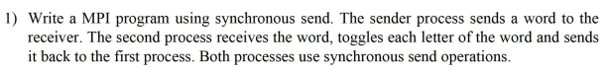
/*
first process sends a string to second process which will toggle the characters and send it back.
use synchronous send.
author: Abhinav Singh Bhagtana
date: 16 Jan, 2026
*/
#include <mpi.h>
#include <stdio.h>
#include <string.h>
#include <ctype.h>

void toggle_char(char *string)
{
for(int i = 0; i < strlen(string);i++)
{
if(isupper(string[i]))
string[i] = tolower(string[i]);
else
string[i] = toupper(string[i]);
}
}

int main(int argc,char *argv[])
{
int rank;
MPI_Init(&argc,&argv);
MPI_Comm_rank(MPI_COMM_WORLD,&rank);

if(rank == 0)
{
char string[] = "HELLO";
char buffer[1024];
MPI_Ssend(string,strlen(string)+1,MPI_CHAR,1,0,MPI_COMM_WORLD);
MPI_Recv(buffer,1024,MPI_CHAR,1,0,MPI_COMM_WORLD,MPI_STATUS_IGNORE);
printf("recieved string: %s\n",buffer);
}
else if(rank == 1)
{
char buffer[1024];
MPI_Recv(buffer,1024,MPI_CHAR,0,0,MPI_COMM_WORLD,MPI_STATUS_IGNORE);
toggle_char(buffer);
MPI_Ssend(buffer,strlen(buffer)+1,MPI_CHAR,0,0,MPI_COMM_WORLD);
}
MPI_Finalize();
return 0;
}
OUTPUT:
$ mpirun -n 4 ./q1
recieved string: hello

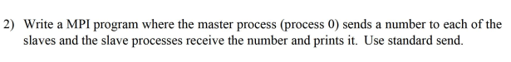
/*
p0 sends number to every other process which print it.
author: Abhinav Singh Bhagtana
date: 17 Jan, 2026
*/
#include <mpi.h>
#include <stdio.h>

int main(int argc,char *argv[])
{
int data,rank,size;
MPI_Init(&argc,&argv);
MPI_Comm_rank(MPI_COMM_WORLD,&rank);
MPI_Comm_size(MPI_COMM_WORLD,&size);

if(rank == 0)
{
int n = 10;
for(int i = 1;i < size;i++)
MPI_Send(&n,1,MPI_INT,i,0,MPI_COMM_WORLD);
}
else
{
MPI_Recv(&data,1,MPI_INT,0,0,MPI_COMM_WORLD,MPI_STATUS_IGNORE);
printf("Process %d received %d\n",rank,data);
}
MPI_Finalize();
return 0;
}
OUTPUT:
$ mpirun -n 4 ./q2
Process 1 received 10
Process 2 received 10
Process 3 received 10
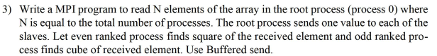
#include <mpi.h>
#include <stdio.h>

int main(int argc,char *argv[])
{
int size,rank;
MPI_Init(&argc,&argv);
MPI_Comm_rank(MPI_COMM_WORLD,&rank);
MPI_Comm_size(MPI_COMM_WORLD,&size);

int buffer[1023];
int buf_size = 1023*sizeof(int);
if(rank == 0)
{
int array[size];
printf("enter %d elements",size);
for(int i= 0;i < size;i++)
scanf("%d",&array[i]);

MPI_Buffer_attach(buffer,1023*sizeof(int));

for(int i = 0;i < size;i++)
MPI_Bsend(&array[i],1,MPI_INT,i,0,MPI_COMM_WORLD);

}
int n;
MPI_Recv(&n,1,MPI_INT,0,0,MPI_COMM_WORLD,MPI_STATUS_IGNORE);

if(rank == 0){

printf("Process %d: %d\n",rank,n);
}
else{

if(rank % 2 == 0)
{
n = n*n;
printf("Process %d: %d\n",rank,n);
}
else
{
n = n*n*n;
printf("Process %d: %d\n",rank,n);
}
}
if(rank == 0)
{
void *dummy;
int dummy_size;
MPI_Buffer_detach(&dummy,&dummy_size);
}

MPI_Finalize();
return 0;
}
OUTPUT:
$ mpirun -n 4 ./q3
enter 4 elements11 21 45 55
Process 0: 11
Process 1: 9261
Process 2: 2025
Process 3: 166375

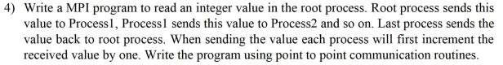
#include <mpi.h>
#include <stdio.h>

int main(int argc,char *argv[])
{
int rank,size;
MPI_Init(&argc,&argv);
MPI_Comm_rank(MPI_COMM_WORLD,&rank);
MPI_Comm_size(MPI_COMM_WORLD,&size);

if(rank == 0)
{
int n;
printf("enter value: ");
scanf("%d",&n);
MPI_Send(&n,1,MPI_INT,1,0,MPI_COMM_WORLD);
}

int rcv;
MPI_Recv(&rcv,1,MPI_INT,rank-1,0,MPI_COMM_WORLD,MPI_STATUS_IGNORE);
rcv++;
if(rank+1 < size)
MPI_Send(&rcv,1,MPI_INT,rank+1,0,MPI_COMM_WORLD);
else
MPI_Send(&rcv,1,MPI_INT,0,0,MPI_COMM_WORLD);

if(rank == 0)
{
int r;
MPI_Recv(&r,1,MPI_INT,size-1,0,MPI_COMM_WORLD,MPI_STATUS_IGNORE);
r++;
printf("Process 0 received value from last process %d: %d\n",size-1,r);
}
MPI_Finalize();
return 0;
}
OUTPUT:
$ mpirun -n 5 ./q4
enter value: 55
Process 0 received value from last process 4: 60

